SQL Final Portfolio Project

# The Data

Import the paintings database, [paintings.tar](https://drive.google.com/open?id=10axLpX_eyTwqPZFFsIuxqKCKxbWbWXde&usp=drive_fs), to Postgres using pgAdmin. Then answer the following questions using SQL. Save the associated queries in a text file.

# The Questions

Create a google doc answering the following questions.

1. What museums have the highest proportion of cubist paintings? What other styles of art do these museums typically display?  
   A screenshot of a computer

   AI-generated content may be incorrect.  
     
   These are the top 10 museums with the highest proportion of cubist paintings.  
     
   A screenshot of a computer

   AI-generated content may be incorrect.  
     
   Museum Folkwang displays Expressionism, Post-Impressionism, Fauvism, Nabi, and Impressionism.  
   Philadelphia Museum of Art has Impressionism, Realism, Romanticism, American Art, Rococo, Baroque, and more.
2. Which artists have their work displayed in museums in many different countries?  
   A screenshot of a computer

   AI-generated content may be incorrect.
3. Create a table that shows the most frequently painted subject for each style of painting, how many paintings there were for the most frequently painted subject in that style, how many paintings there are in that style overall, and the percent of paintings in that style with the most frequent subject. Exclude cases where there is no information on the subject of the painting. Format the table and copy it into the google doc.  
   A screenshot of a computer

   AI-generated content may be incorrect.

# Creating the Link

Create a google doc summarizing your findings. Set the doc as viewable by anyone with the link:



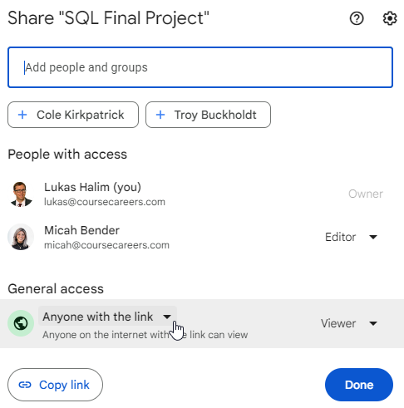

You will include this link in your CourseCareers profile.